Reflective Journal

Student name: **Joey Tatú - 15015556**

Programme: **BSc (Hons) in Computing – Software Development**

Month: **October 2019 (Week 3 – 6)**

Contents

My Achievements 1

Week 3 (30/09): 1

Week 4: 1

Tuesday, Wednesday and Thursday: 1

Friday: 1

Week 5 (07/10): 1

Monday: 1

Tuesday 3

Wednesday 3

Thursday 3

Friday 3

Saturday 3

Sunday 4

Week 6 4

Monday 4

My Reflection 4

Intended Changes 4

Supervisor Meetings 4

# My Achievements

## Week 3 (30/09):

I was sick this week, so I didn’t get anything done.

Week 4:  
Monday:

I worked on the Project Proposal today. I took parts of it from my Project Proposal last year. I emailed Eamon and Paul to ask them if references were needed. I assume they are.

I also worked on the Lab from Week 3 in Data Application Development. Tomorrow and Thursday, I want to do research on the technologies for websites dealing with appointments. I think Java and SQL will be sufficient, but if I can find something better, that world be good too.

### Tuesday, Wednesday and Thursday:

I worked on the Data Application Development (DAD) labs, as well as doing tutorials on Python. I felt Python isn’t fully explored in the DAD module, so I decided to get a head start while I could.

### Friday:

Friday was a bad day for me, mental health wise and I didn’t do anything. I try to keep my weekends free.

## Week 5 (07/10):

### Monday:

**09:10 –** Talked with my supervisor, Paul Stynes about my project. He reviewed my video again and discussed with me about the idea. He said that the idea is similar to a bricks and mortar store where everything is done manually, but he suggested looking at Google Scholar and looking for automation and delving deeper into the Artificial Intelligence part of the project.

**09:30 –** Paul did a seminar about Software Requirements.

1. Use Cases. Actor -> Use Case
2. NO! Use Case to Actor
3. Use Cases to Use Cases
4. 4 to 6 Use Cases.
5. Functional Decomposition is Actor -> Use Case -> Actor. (If it gets big – NO)

**10:00 –** I have been looking at the link Paul provided and I am understanding the general concept. What I have provided is a brick and mortar scenario where the tattooist (etc) and the client are doing things manually. And I want to automate this process. But the question remains; “how do I do that?” Seemingly with my project idea last year and this year, I seem to go for something complicated and not really discussed in a scholar environment. It’s a little bit frustrating.

From: <https://pdfs.semanticscholar.org/65a6/7db9ba8992b27bfda0a134afa1397e2c8af7.pdf> :

“In-store Technologies in the Retail Servicescape”.

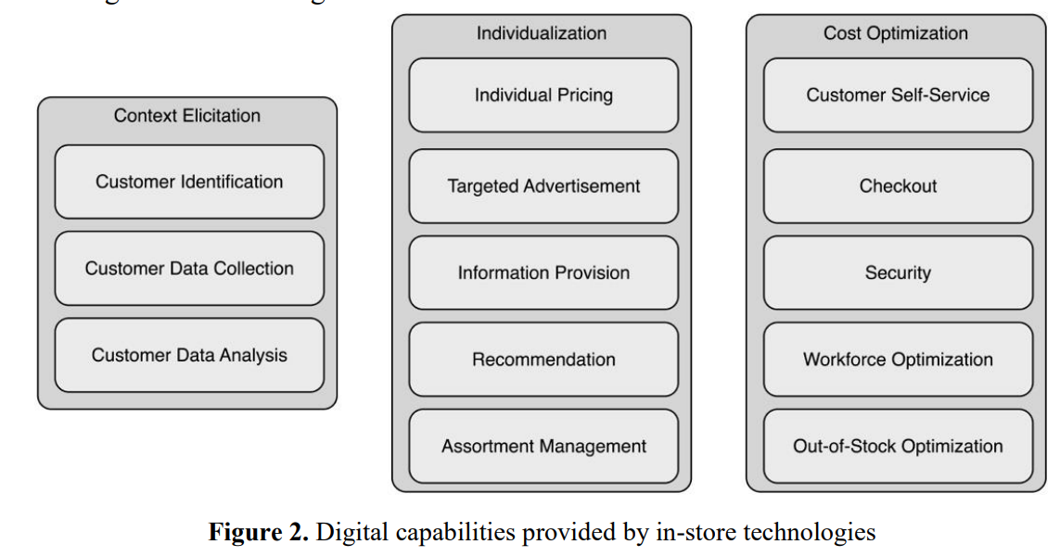

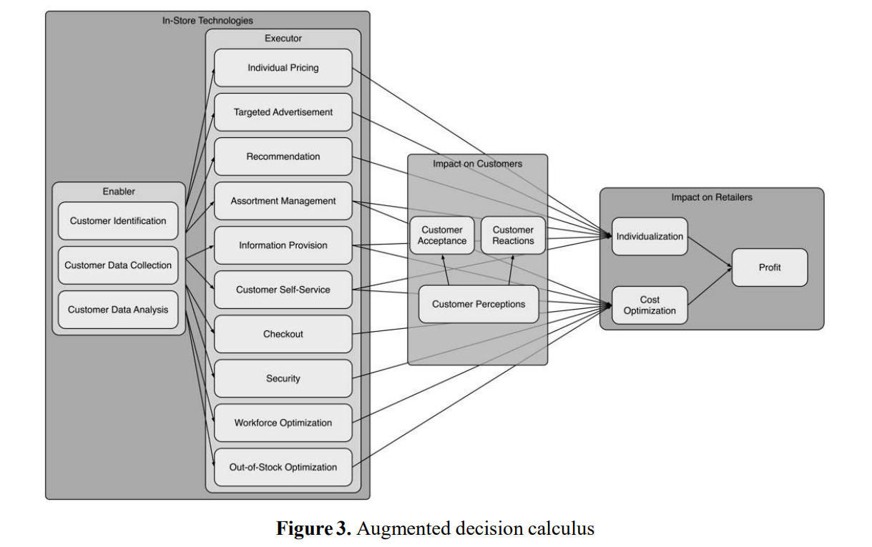

I was thinking of how I could do something similar but change it for body modification’s artists and clients. It makes sense to me.

### Tuesday

I went to my Data Application Development (DAD) class and worked on the sample retrieving data from Twitter (ETL Airlines example). The “twitteR” package for R has not been updated to include a “language” variable, and I wasn’t able to complete it. I contacted my lecturer and he is aware of this and will look at it on Thursday.

After this class, I worked on DAD’s Lab 4 from 11am until 3. I got it finished. After this, I felt like my brain was turned into mush. I think I worked too long without a break. I had planned to work on my Software Project’s (SP) Proposal afterwards, but my brain needed a rest. I nearly forgot that Helen Conway had organised LinkedIn photos from 3 – 4pm, so I got that done instead and then went home.

### Wednesday

I went to my local pharmacy to get my flu jab at around 11am. I started working on SP’s Proposal at around noon. After talking with my supervisor on Monday, I want to include personalisation on the project. I was looking at Google Scholar articles to add more research to the Proposal. I had a mini site set up for a survey, but only one person answered it before the deadline, so it will not be used. I have also retracted my Ethics Form on Moodle, as it’s not needed anymore. The survey was the only reason for the Ethics Form. External research will be used instead. I emailed my supervisor for feedback on my Proposal.

### Thursday

I worked on the DAD Lab 5 and the retrieving data from Twitter. Those are very outdated. They are using a R package called twitteR, and it hasn’t been updated since 2016. I wanted to get it working, because I felt it was important to know how to retrieve data and actually do it. So, I spent after my DAD class (9-11) on those.

I found that rtweet worked and I had to rework the code to get it to actually work. My brain felt like mush afterwards though, as I think it was a bit above me. But I was pretty proud of myself for getting it working. Lab 5 is Week 6’s work, so hopefully, this gives me more time to work on DAD’s Project Proposal next week as Reading Week, I want to focus on DAD – CA1 in Week 8.

### Friday

I don’t know whether it was my flu shot or a result of college work, but I slept until about 12:30pm. However, I worked on my SP Proposal for an hour. In all honesty, I was a little disheartened by my supervisor’s feedback. I followed my Proposal by some of last year’s. It seems like a lot of work just for a proposal. I know the Requirements Specifications is more intense, but wasn’t expecting the

### Saturday

From 9:30 to 11:30am and 12:30 to 4pm, I worked on SP Proposal. I added the architecture diagram, explained it and began working on the Testing section. I’m not sure I’m doing it right though, especially with the feedback. Onwards and upwards, they say. I’m really opting for a high grade, so really any feedback this early on is really valuable.

### Sunday

Honestly, I didn’t do anything today in regard to college work.

## Week 6 (21/10)

### Monday

Today, I had planned to meet with my supervisor Paul, but he is on annual leave this week. I emailed a copy of my Project Proposal for him to look at as it currently looks like today. Today, I am working more on my Project Proposal and I’m hoping I’m doing it right. I do plan on testing it out myself as I don’t wish to do the ethics form. I feel I have done my Project Proposal to the extent that I don’t feel I can add anything else. I feel it’s complete.

### Tuesday – Friday

I was feeling a bit poorly and exhausted. I didn’t do much work at all. I think it was an after-effect of the flu vaccine. My immune system seems to be much lower than normal.

## Week 7

### Monday to Tuesday

I’m still feeling a little poorly, but gradually improving. I didn’t do any college work.

### Wednesday

Today, I am working on my Datasets Description for my Data Application Development Project. I am also working on CA1 prep. The CA is on next Thursday.

# My Reflection

This month has gone well. I am proud of the work I’ve completed and I feel that I am on track for the Software Project and Data Application Development. With my Weekly Planner, I feel I am able to schedule my time accordingly.

# Intended Changes

I do not feel I need to change anything. I am on track.

My only concern is meeting with my supervisor. I have been trying to see him every week, but schedule conflicts on his part are unavoidable. I really wish to do my best and get all the feedback I can.

# Supervisor Meetings

|  |  |  |  |
| --- | --- | --- | --- |
| **Supervisor Meeting Record** | | | |
|  | | | |
| **Student: Joey Tatú** | **Student ID: 15015556** | | **Supervisor: Paul Stynes** |
|  |  | |  |
|  | **Date: 14/10/19** | **Time: 11:15** |  |
|  | | | |
| **Order** | **Item** | | **Status** |
| **1** | **What I’ve done since last meeting:**  I had a quick meeting with Paul Stynes earlier at around 09:10. We just went through the general project and he suggested looking at making a bricks-and-mortar scenario and making it automatic. He also provided a link to Google Scholar for me to browse through related papers.  I was looking at these articles this morning and found one that peaked my interest. I printed off a figure showing a possible way I could evaluate the process. | |  |
| **2** | **Questions or issues?**  I have no questions or issues at this stage. | |  |
| **3** | **Feedback**  Paul had said to look at “personalisation”, “implementation” and looking at “optimisation problems”. | |  |
| **4** | **What I plan to do before the next meeting**  I plan to do more research (specifically looking at the feedback from Paul) and finish the Project Proposal by Monday at the absolute latest. | |  |
| **5** | **The next thing?**  After the Proposal, I will be focusing on the Requirements Specification. I expect to look at my previous year’s Requirement Specifications for helpfulness. After this is done, I will start working on the prototype. | |  |
| **6** | **The Next meeting**  Ideally, same time next week, if Paul agrees. I will expect to be talking to him about my Proposal and I will send him a copy for him to look at before the next meeting. | |  |

|  |  |  |
| --- | --- | --- |
| **Student Signature:** | ____________________________ | Date: ____/____/2019 |
|  | JOEY TATÚ |  |
|  |  |  |
|  |  |  |
|  |  |  |
| **Supervisor’s Signature:** | ____________________________ | Date: ____/____/2019 |
|  | PAUL STYNES |  |